PROJECT ARTICLE – NCHRP 08-151

Introduction

State Departments of Transportation (DOT) are no strangers to uncertainty and disruption. Whether these disruptions come from extreme weather events, emerging technologies, or economic uncertainty, state DOTs—as stewards of vital transportation systems—must be ready to avoid, mitigate, respond to, and recover from disruptions as efficiently as possible. Incorporating a formal risk management process in agency decision-making is one way state DOTs can mitigate these disruptions.

NCHRP 08-151 Risk Management at State DOTs: Building Momentum and Sustaining the Practice, was designed to engage with state DOT practitioners and private sector representatives to develop tools, resources, and a website geared toward helping state DOTs advance their risk management practices. The project resulted in a website and digital content housed on the AASHTO Transportation Management online portal and can be found here. The site provides information, tools, and other resources designed to support state DOT practitioners as they build and sustain formal risk management practices within their agencies. The website is designed to support state DOT practitioners based on their individual role by providing resources to help no matter where the agency is on the risk management adoption spectrum–building or sustaining.

Risk management is the process to identify, evaluate, respond and prioritize threats and opportunities through various strategies and tools, which allows individual risk events and/or overall risk to be proactively understood. Risk management can take place at different levels of the organization supporting different objectives.

Problem
State DOTs face risks every day. Many state DOTs have established formal or informal risk management processes to help plan and prepare for threats and disruptions so they can avoid, minimize, or bounce-back quickly and safely. Research over the last several years yielded many useful tools and resources that helped state DOTs advance their risk management process. While these tools and resources have been instrumental in moving the practice of risk management forward, state DOTs across the country are in various stages of adoption and need more tailored resources designed to help advance the state of the practice no matter where the agency is on the risk management adoption spectrum.

Solution
The overarching goal of the research conducted under NCHRP 08-151 was to develop content for state transportation agencies and their staff on how to build and sustain the use of formal risk management processes and policies. To accomplish this goal, a survey of state DOT practitioners and industry experts was conducted, and a virtual industry roundtable was convened. The research project also included a literature review and practice gap assessment. Four case study examples were developed, and a website was designed for state DOT staff. This website will be housed on the American Association of State Highway & Transportation Officials (AASHTO) Transportation Management Hub (found at https://www.transportationmanagement.us).

The completion of these tasks ensured that the content developed for the website filled information gaps in the practice and supported state DOT practitioners at various stages of risk management adoption and implementation. The research and content development focused on the following topics:

- Value proposition: how to establish and communicate the value of risk management for decision-making across state DOTs;
- Organizational change: how to initiate organizational changes at all levels that enable and strengthen the use of formal risk management;
- Promotion: guidelines and examples on how leadership, mid-management, and others can champion risk management within the organization; and
- Mindset and culture: how to develop and sustain a risk-management mindset and agency culture that integrates risk management across programs and into key decision-making processes.

This research included an in-depth review and evaluation of risk management experience at state DOTs and other public and private sector organizations, with a particular focus on organizational traits and change management strategies needed to overcome barriers to implementing and sustaining formal risk management.

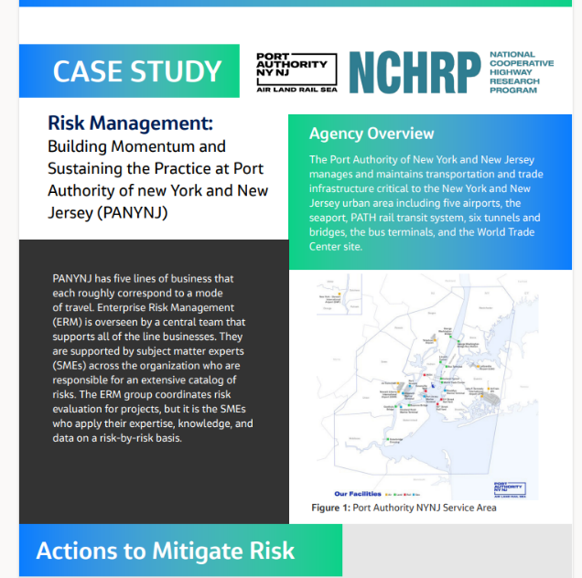
In addition to the engagement with state DOT practitioners and industry representatives, “deep dive” risk management case studies that included discussion around key themes These covered risk management practices at the Port Authority of New York and New Jersey, the Central Federal Lands Highway Division, Vejdirektoratet—the Danish Road Directorate, Maine DOT, and Utah DOT. The “deep dive” approach provided the opportunity to closely examine how the spotlighted agencies applied risk management processes and policies and what lessons were learned along the way. State DOT practitioners were asked questions about how they and their respective transportation agencies addressed processes or policies that needed to be changed and how they accomplished those changes. Each case study provides information about lessons learned, achieved benefits, change management, needed employee skills and training, and specific steps to build and sustain a successful risk management practice.

The research produced a website and digital content with information, tools, and resources designed to support state DOT practitioners as they build and sustain formal risk management practices within their agencies. The final website is for inclusion on the AASHTO Transportation Management Hub and includes information organized by state DOT role—Executive, Program Manager, Project Manager—and where the agency finds itself on the spectrum of risk management process adoption—building or sustaining.
Core elements include resources designed to help state DOT practitioners assess where they are on the risk management spectrum and what steps can be taken to advance the practice within the agency. Examples include communication strategies, how-to guides with step-by-step processes to help state transportation agencies develop risk management processes, and policies at all levels—enterprise, program, and project. The overall design and functionality of the website along with proposed content were reviewed before a focus group comprised of state DOT practitioners. The focus group provided valuable feedback and ensured that the final website includes appropriate content that is informative and easy to use.

- Content designed for the website covers the following topics:
- The value of risk management in transportation decision-making and how that value can be communicated.
- Relevant concepts of change management.
- Commonly encountered barriers to adopting and sustaining formal risk management and strategies to overcome these barriers.
- Ways to foster an organizational culture that supports the use of formal risk management.
- Examples of best practices deployed by state DOTs in implementing and sustaining successful risk management programs.
- Insights about risk management practices drawn from the public and private sectors.
- Communications pieces focused on key topics of risk management, organizational change, and implementation designed for outreach within a state DOT and to external partners.

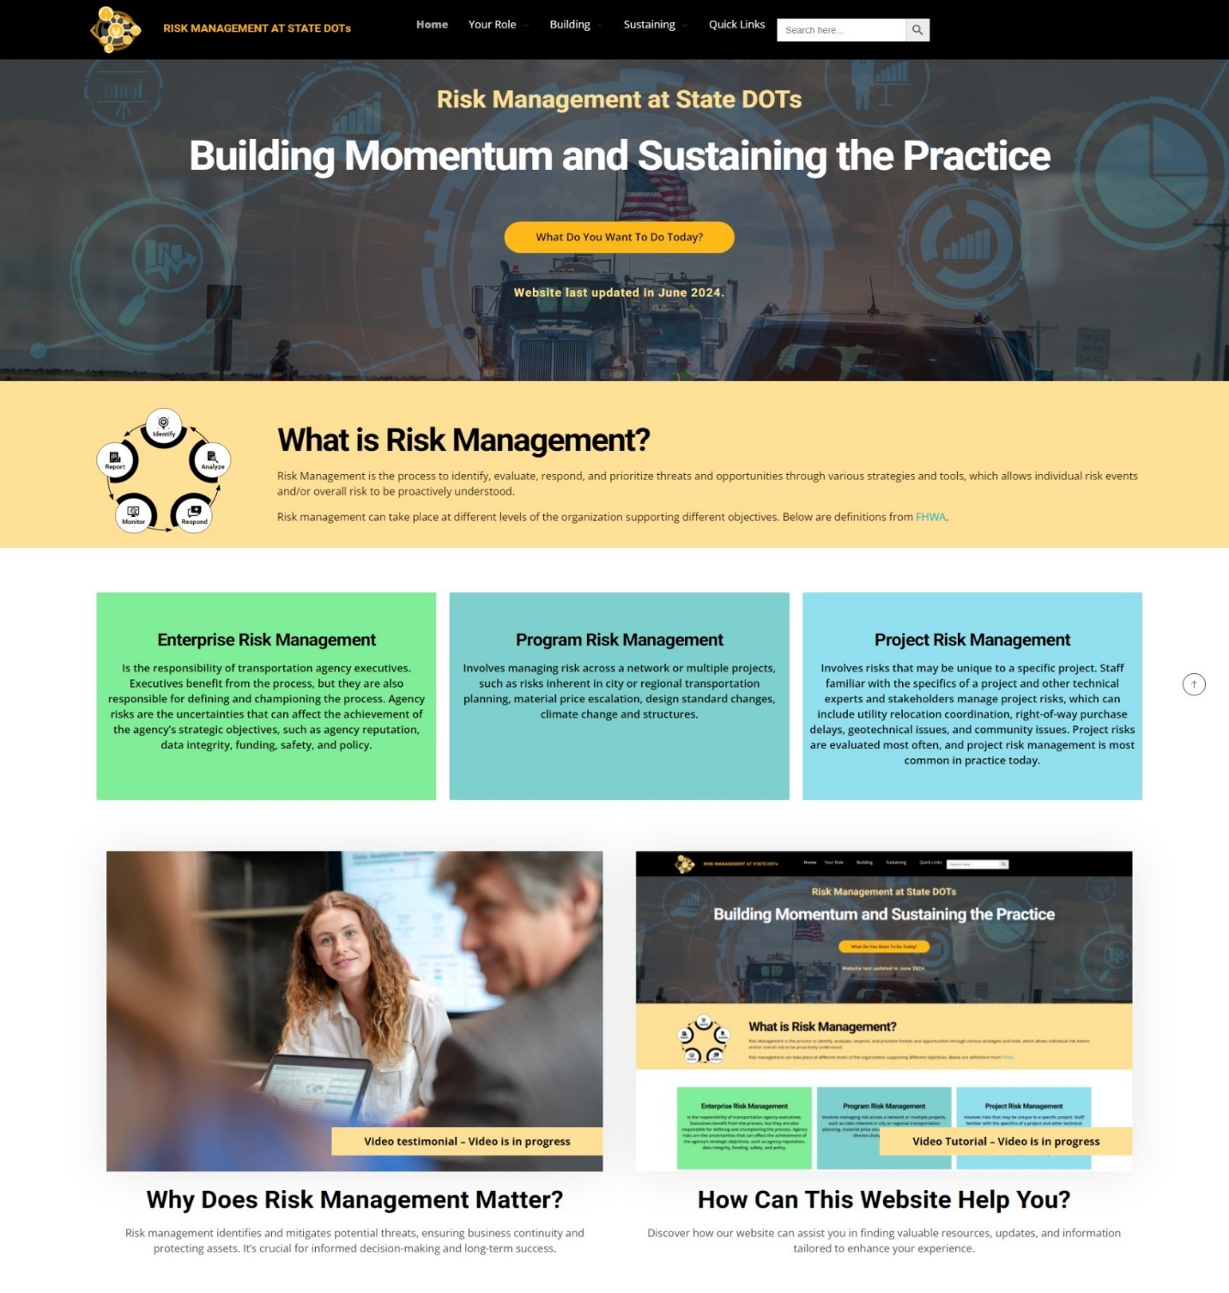

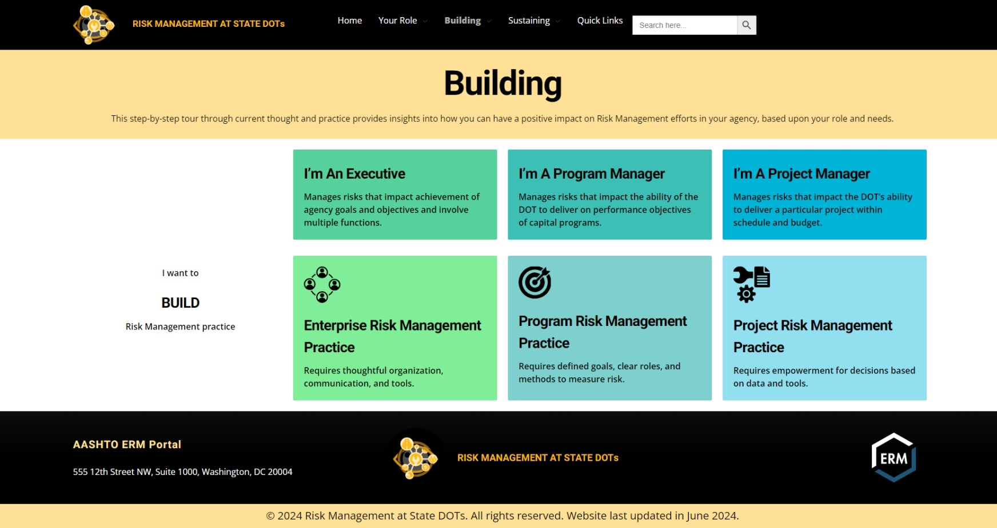
Conclusion
As state DOT practitioners continue to make advancements in how they identify and mitigate risk, research conducted through NCHRP 08-151 provides needed resources and tools that address identified gaps in knowledge. Having these resources delivered digitally will ensure state DOT practitioners have access to a one-stop-shop with lessons learned, how-to guides, and other resources designed to fit their individual needs no matter their specific role within the agency or where the agency is on the risk management process maturity spectrum.

